|  |  |
| --- | --- |
|  |  |

|  |
| --- |
|  |

|  |
| --- |
| IP Centrex |
| Professional Toolbar User Guide |
|  |
|  |
| © Spark Digital, a division of Spark New Zealand Trading Limited 2014  Spark Digital owns copyright and all other intellectual property rights in this document. You may not copy or redistribute any portion of this document without Spark Digital’s permission. |

# Table of Contents

Introduction 4

About the IPC Professional Toolbar 4

Related User Guides 4

Power Outages and Availability of Emergency Call Services 4

The Toolbar buttons 5

Internet Explorer and Firefox toolbars 5

Outlook toolbar 5

Button Legend 5

Button descriptions 6

Getting Started 10

Configuring the Toolbar 10

Configure Your Server Connection 10

Configure Your General Settings 11

Complete the Toolbar Configuration 11

Changing Your Password 11

Using Professional Toolbar 12

Make a Call 12

Call Notifications 16

Receive a Call 16

Transfer a Call 17

Call Options 18

Voicemail 19

CommPilot Express 19

Configure Call Features 21

Services Dialog Window 21

Service Dialog Pages 21

Outgoing Calls 26

Call Control 27

Troubleshooting 28

Warning message displayed when opening the Group Directory, Call History, Search or Personal Directory 28

Professional Toolbar Not Visible in Either Microsoft Internet Explorer or Microsoft Outlook 28

Error Message – “You have not been licensed to Use IP Centrex Professional Toolbar. Please contact your service provider” 29

Professional Toolbar is Not Visible in Internet Explorer 30

Introduction

About the IPC Professional Toolbar

IP Centrex (IPC) Professional Toolbar is an add-in toolbar for Microsoft Internet Explorer, Microsoft Outlook and Mozilla Firefox and provides access to IPC telephony services and call management features within these browsers and the Outlook mail client.

Note:

* This user guide is specific to Release 17 of IPC Professional Toolbar and assumes that you already have IPC Professional Toolbar installed on your computer.
* If you do not already have the software installed please refer to the IPC Software Installation Guide and install the software.

Related User Guides

IPC User Guide

Provides detail on using the IPC service.

IPC Reception Console User Guide

Provides detail on the use of the IPC Reception Console.

IPC Web Portal User Guide

Provides detail on the use of the IPC Web Portal.

IPC Web Portal Administrator Guide

Provides detail on the use of the IPC Web Portal from an Administrators perspective.

IPC Software Installation Guide

Provides detail on the installation of IPC software.

Power Outages and Availability of Emergency Call Services

Emergency 111 calls will not be able to be made in the event of a service outage, power failure or disruption. Spark recommends that clients maintain additional means to enable emergency service calling.

The Toolbar buttons

Internet Explorer and Firefox toolbars

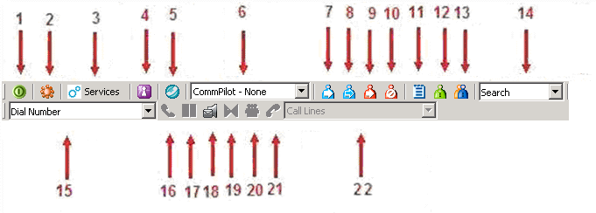

Outlook toolbar

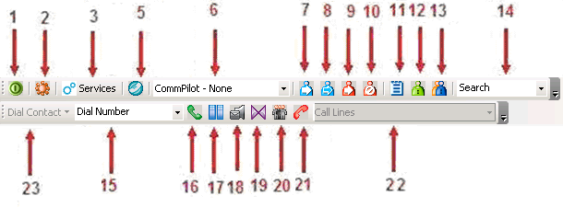

Button Legend

|  |  |  |
| --- | --- | --- |
| 1. |  | Login |
| 2. |  | Options dialog |
| 3. |  | Services |
| 4. | portal login | Portal Login |
| 5. |  | Simultaneous Ringing |
| 6. |  | Current CommPilot Express Profile |
| 7. |  | Call Forwarding Always |
| 8. |  | Call Forwarding No Answer |
| 9. |  | Call Forwarding Busy |
| 10. |  | Do Not Disturb |
| 11. |  | Call History |
| 12. |  | Personal Directory |
| 13. |  | Group Directory |
| 14. |  | Directory Search Box |
| 15. |  | Dial Number Box |
| 16. |  | Answer |
| 17. |  | Hold |
| 18. |  | Voice Mail |
| 19. |  | Call Transfer |
| 20. |  | Conference Call |
| 21. |  | End Call |
| 22. |  | Dial Contacts |
| 23. |  | Call Lines (line in use) |

Button descriptions

Login

 - Logs you in and out of Professional Toolbar.

The colour of this icon indicates your login status:

* a grey button indicates that you are not logged in.
* a green button shows that you are logged in.
* a disabled (dark grey) button shows that Professional Toolbar is attempting to log you in.
* a red button indicates that your last login attempt failed.

Options

 - You can configure your account, connection settings, and dialling rules through this dialog window. This icon is depressed when open.

Services

- You can configure the Call Management services provided by Professional Toolbar. This icon is highlighted when in use.

Portal Login

portal login - Click this button to open your web portal in a browser window. Your login credentials for the portal may be automatically entered for you, if you have previously checked the remember password option on the web portal login page. Once you have logged in you can configure various aspects of call treatment and other features of the service.

Simultaneous Ringing

 - Allows you to establish a list of up to ten additional phone numbers that ring each time your number receives a call. While the service is enabled the icon remains highlighted. If Simultaneous Ringing is not yet configured and you click this icon to activate the service, Professional Toolbar opens the Service dialog window to the Simultaneous Ringing page to allow you to enter other numbers to be rung simultaneously.

Current CommPilot Express Profile

 - The drop down box sets the current CommPilot Express profile. An Express profile determines the way the system handles incoming calls for you. You can configure the settings for CommPilot Express profiles in the Services dialog window.

Call Forwarding Always

 - Automatically forwards all incoming calls to a specified phone number. When this service is enabled, this icon remains highlighted. If Call Forwarding Always is not yet configured when you click on this icon to activate the service, Professional Toolbar opens the Service dialog window to the Call Forwarding Always page to allow the service to be configured.

Call Forwarding No Answer

 - Automatically forwards all incoming calls to a specified phone number when you do not answer the call within a specified number of rings. While the service is enabled, the icon remains highlighted. If Call Forwarding No Answer is not yet configured when you click on this icon to activate the service, Professional Toolbar opens the Service dialog window to the Call Forwarding No Answer page to allow the service to be configured.

Call Forwarding Busy

 - Forwards all incoming calls to a specified phone number when your phone is busy on other calls. While the service is enabled, this icon remains highlighted. If Call Forwarding Busy is not yet configured when you click on this icon to activate the service, Professional Toolbar opens the Service dialog window to the Call Forwarding Busy page to allow the service to be configured.

Do Not Disturb

 - Automatically forwards all incoming calls for you to the Voice Messaging service, or plays callers a busy tone if there is no Voice Messaging service configured. While the service is enabled, this icon remains highlighted.

Call History

 - Opens the list of your most recent received calls, missed calls, and dialled calls. Information will open in the currently opened tab or window of a web browser.

Personal Directory

 - Allows you to view phone numbers saved in your personal directory and to dial them by clicking them. Information will open in the currently opened tab or window of a web browser.

Group Directory

 - Allows you to view phone numbers saved in the group directory and to dial them by clicking them. Information will open in the currently opened tab or window of a web browser.

Search

 - Allows you to enter criteria and search for contacts in the Group and Outlook Express directories. Information will open in the currently opened tab or window of a web browser.

Dial Number

 - Dials a specified number. You may type in a number directly, paste the number in, or select from the drop down list of the recently dialled numbers.

Answer

 - Allows you to toggle between active calls. It will also resume the currently held call.

Hold

 - Puts the current call on hold.

Dial Voicemail

 - Dials into the IPC supplied Voice Messaging service to allow message retrieval. If you use a third party Voice Messaging solution other than the one provided with IPC, then you will need to access your Voicemail as prescribed by your Voicemail provider.

Call Transfer

 - Transfers the current call to another phone number. You can either do a ‘blind’ or ‘supervised’ call transfer.

Conference Call

 - Starts a conference call that can include two other parties. This button only becomes enabled when you are connected to two other parties at the same time. The button becomes depressed when the conference call is in progress.

End Call

 - Ends the current call.

Dial Contact

 - Dials the business, home, or mobile number of a selected contact within Microsoft Outlook.

Call Lines

 - Displays a list of active conversations including the numbers you are currently connected to. You can toggle between conversations by using a drop down menu and then use Hold / Answer buttons to Hold / Resume conversations.

Getting Started

Configuring the Toolbar

When you log in for the first time, you will need to configure your connection settings as described below. Once these settings are configured you do not need to configure them again.

|  |  |
| --- | --- |
| 1. To login 2. Click the ‘Login’ button  on the toolbar (this opens the Options dialog window). 3. Click Account. 4. Enter the username and password for your Spark Digital account in the fields provided*. 5. Check the Save Username and Save Password options if you want to avoid being prompted for this information next time you log in. Your password is encrypted for security reasons. |  |

1. Click Apply.

* Contact your System Administrator if you do not know the username and password of your IP Centrex account.

Note: If you use both a mobile phone and a fixed desk phone with the IPC service you must select only one of those devices to be associated with the IPC Professional Toolbar at any one time. You select which device the toolbar is linked to by the username you specify in the credentials you enter when logging into the Professional Toolbar,

Configure Your Server Connection

|  |  |
| --- | --- |
| To configure your server connection   1. Click on Connection. 2. Enter the Server Host Address and Host Port number in the fields provided. Consult your system administrator for the necessary values, otherwise defaults are shown on the picture below. 3. Click Apply. |  |

Configure Your General Settings

|  |  |
| --- | --- |
| To configure your general settings   1. Click General. 2. Check Auto login when connected to network if you wish to automatically connect Professional Toolbar when you start Internet Explorer, Firefox, or Outlook. 3. Click OK. |  |

Complete the Toolbar Configuration

After you have entered your configuration details, click on the ‘Login’ button SC3 again to complete the login process.

If your configuration and credentials are correct, then the ‘Login’ button should turn green and the buttons on your Professional Toolbar will become enabled.

Disabled Internet Explorer/Firefox Professional Toolbar



Enabled Professional Toolbar



Once you have configured Professional Toolbar once, you can use it without having to provide that information again.

Changing Your Password

You can change your password at any time using the web portal <http://ews.telecom.co.nz> . Enter your IP Centrex account username and password, then click on Passwords link and change it.*

If your password is due to expire, toolbar will automatically prompt you to change the password, so you don’t have to use the web portal to do it.

Once you have configured Professional Toolbar, you can use it without having to provide that information again.

* Contact your System Administrator if you do not know your IP Centrex username and password.

Using Professional Toolbar

When you have successfully logged into Professional Toolbar the relevant buttons are enabled for you to use.

You can then start using Professional Toolbar in the ways below.

Make a Call

This section provides instructions for the different ways to make a call. You can dial a:

* new number
* previously dialled number
* number on a webpage
* number on an email (Outlook 2003 only)
* number in a group directory
* number in a personal directory
* number in your call history
* number in a search result
* previously searched number
* number in a contact list

Note: If you are using fixed IPC phone to originate a call, your phone will go off hook (speaker phone mode) and will dial this number straight away.

If you are using your IPC mobile, then your mobile will ring first, you would need to answer it and then the call will be placed to the dialled party.

Dial a New Number

To dial a new number type the number into the ‘Dial Number’ box  and press Enter on your keyboard.

To end the call, click the ‘End’ button .

Dial a Previously Dialled Number

To dial a previously dialled number

Select a number by clicking on the arrow at the right-hand side of the ‘Dial Number’ box . A list of the last 10 previously dialled numbers is displayed.

Click on a number in the ‘Dial Number’ list.

Press Enter on your keyboard.

To end the call, click the ‘End’ button .

Dial a Number on a Webpage

|  |  |  |
| --- | --- | --- |
| To dial a number that is listed on a webpage  Select the phone number displayed on a web page by highlighting the number with your mouse.  Right-click the highlighted phone number and click ‘Dial’ on the pop-up window. | SC9 | |
| Dial a Number on an Email  NOTE: At the time this document was printed, this feature was only available in Outlook 2003. Outlook 2000 and Outlook 2007 do not support the ‘Dial’ feature.  To dial a contact from an Outlook email, follow these steps:   1. Open, or preview, the email that contains the phone number you wish to dial. 2. Make sure that the email is in HTML format 3. Use your mouse to highlight the number you wish to dial. 4. Right-click the highlighted number. 5. When the drop-down list appears click on Dial. The phone call is now placed. | |  |

Dial a Number in a Group Directory

Your group directory is a group of people within your company who are using the IP Centrex. You can directly dial any number stored in your group directory.

To dial a number in the group directory

* Click the ‘Group Directory’ button  on the Professional Toolbar.
* Click on desired phone number. Professional Toolbar then places the call.

Note: Users with Microsoft Windows XP Service Pack 2 installed may encounter a warning when opening the Group Directory. For more information, see the section at the end of this document entitled Troubleshooting.

To sort the group directory, click on a column header. The table is sorted, in descending order, according to the information in the column you selected.

To change the sort order between descending and ascending, click on the same column header again.

The directory can be printed using the standard print function of the Web Browser.

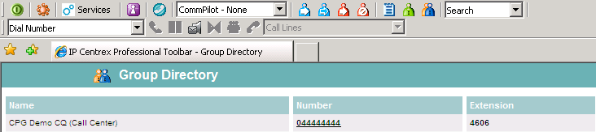

Dial a Number in a Personal Directory

You can directly dial any number stored in your personal directory (which can be uploaded via your Web Portal – see the IPC Web Portal User Guide for information on using the Web Portal).

To dial a number in the Personal Directory

1. Click the ‘Personal Directory’ button  on Professional Toolbar.
2. Click the desired phone number. Professional Toolbar then places the call.

To sort the personal directory, click on a column header. The table is sorted, in descending order, according to the information in the column you selected.

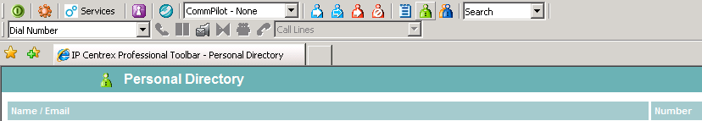

Dial a Number in Your Call History

Call History allows you to view your missed , received , and dialled calls . These are listed in reverse chronological order. To dial a Call History number

1. Click the ‘Call History’ button  on the toolbar to open Call History
2. Click on the desired phone number. Professional Toolbar automatically places the call.
3. You can delete a number in a call history by checking the box against the entry you wish to delete and then clicking on Clear  button on your top right.

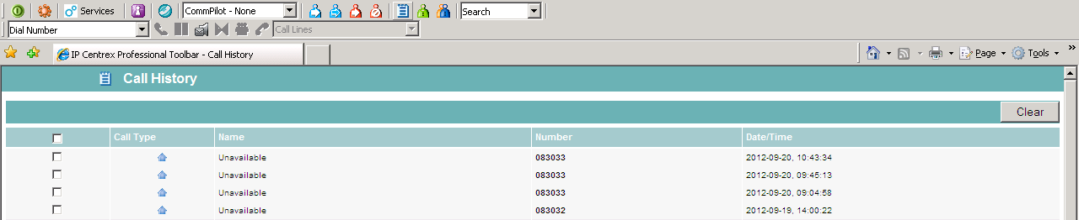

Dial a Number in a Search Result

Use the ‘Search’ drop-down list to look for a user or contact. The search results include all users in the Group and Outlook directories. Your search returns all users that match your criteria in any field. For example, if you enter “mo” as your criteria, your search might return users with the first name “Monica” or with the last name “Moore”

You can also search for users by phone number.

To search for a user:

1. Type your criteria in the Search box .
2. Press Enter on your keyboard to execute the search.
3. Professional Toolbar displays the results of your search. To dial a number click the phone number you want to dial.
4. To end the call, click End.

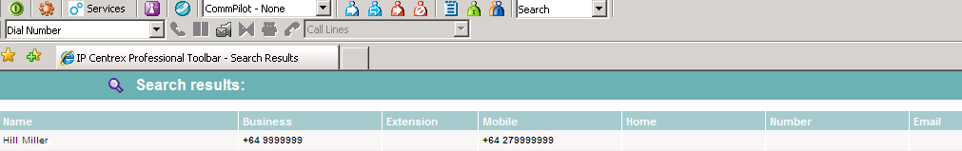

Dial a Previously Searched Number

To dial a previously searched number:

* Select a previous search criteria by clicking on the arrow at the right-hand side of the Search box. A list of previous search criteria is displayed.
* Select an item in the list. Professional Toolbar displays the results of your search.
* Click the phone number you want to dial.
* To end the call, click End.

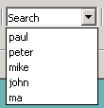

Dial a Number in a Contact List

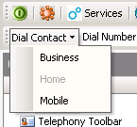With Professional Toolbar you can dial the home, business, or mobile number of any contact directly within Microsoft Outlook.

To dial a number in a contact list:

* Click Contact in the folder list.
* Select the contact you wish to call from the contact list.
* On the Professional Toolbar within Outlook, click the arrow at the right-hand side of the Dial Contact drop-down list,
* Select the type of number to call.

Call Notifications

Call Notification on Incoming Calls

|  |  |
| --- | --- |
| When you make or receive a call, Professional Toolbar displays a notification window above the system tray that includes the other party’s phone number and other information about the call.  The call notification window stays open for the duration of the call. | SC17 |

If you make or receive another call while the first notification window is open, a new call notification window will stack on top of the first window.

Receive a Call

Answer a Call

|  |  |
| --- | --- |
| When you receive a call, Professional Toolbar displays a call notification window on top of the system tray. You can answer this call by picking up your handset.  Note: If you are using fixed IPC phone to answer a call, you can click on the notification window and your phone will go off hook (speaker phone mode). | SC17 |

Note: If you are using your IPC mobile, then your mobile will ring and you would need to answer it by pressing a button on the mobile.

Note: When using Professional Toolbar with Outlook, if the incoming call does not provide a name for the calling party then Professional Toolbar checks the number against the User’s Outlook contacts and displays the corresponding name if it finds a match.

Note: For both fixed and mobile IPC phones you have the option to ignore incoming call directly from the call notification pop-up window. In this case the call will be handled as if you were unavailable.

Ignore a Call

|  |  |
| --- | --- |
| You can ignore an incoming call directly from either Professional Toolbar or from the call notification window.  To ignore a call from Professional Toolbar, click the ‘End’ button  on Professional Toolbar. | SC18 |

To end a call from the call notification window click the End icon in the call notification window.

Transfer a Call

Blind Transfer

This method is used to transfer an initial caller to another number without providing an introduction to the destination party.

Calls may be transferred this way while active, held, or ringing on your phone. In the latter case, the system redirects the call before it is answered.

To make a blind transfer:

1. If you are already on a call, you can begin a blind transfer by dialling a number on a phone or selecting a number using any of the methods described earlier in the section Make a Call.
2. When a call to a second number is placed, this automatically puts the first call on hold if the first call is not already on hold.
3. You initiate the transfer by clicking the ‘Transfer’ button  on Professional Toolbar. The initial caller is now connected to the number you selected.

Supervised Transfer

This method is used to transfer a call to another number and provide an introduction to the destination party. Calls may be transferred this way while active, held, or while ringing on your phone.

When a supervised transfer is initiated, the original call is placed on hold and a call is made to the party intended to receive the call. The receiving party may be consulted prior to accepting the call.

For example if you are already connected to Monica and you wish to transfer the call to Bob then you can do so as follows:

1. Dial Bob’s number on a phone or select his number using any of the methods described in section Make a Call.
2. When the call is placed to Bob, Monica will be automatically put on hold.
3. The first party (Monica) has to wait until the called party (Bob) accepts the call. You can then consult the third party (Bob) and then click the Transfer’  button to connect the parties. You are then disconnected from the call at that time.

Call Options

Hold a Call

To hold a call (put a call ‘on hold’), you click the ‘Hold’ button  on Professional Toolbar. The Hold button is greyed out to indicate that the call is now held.

To resume a held call, you click the ‘Answer’ button  on Professional Toolbar. The hold button returns to its normal state to indicate the active status of the call.

Initiate a Conference

Note: If you use both a mobile phone and a fixed desk phone with the IPC service you must select only one of those devices to be associated with the IPC Professional Toolbar at any one time. You select which device the toolbar is linked to by the username you specify in the credentials you enter when logging into the Professional Toolbar,

Initiate a Conference from a Mobile Phone

You can initiate a conference with two parties directly from Professional Toolbar. You have to have at least two currently active calls (numbers you are connected to are listed in the Call Lines drop-down list), . These calls may have been initiated either by you or by the other parties.

Initiate a Conference from a Fixed Desk Phone

You can initiate a conference with two or more parties directly from Professional Toolbar. You have to have at least two currently active calls (numbers you are connected to are listed in the Call Lines drop-down list), . These calls may have been initiated either by you or by the other parties.

To start the conference, you click the ‘Conference’ button  on Professional Toolbar.

Note: All calls currently in the Call Lines drop down list will be added to the conference.

Drop one participant from the Conference

To drop only one participant from the conference, select the participant’s number from the Call Lines drop-down list and click the ‘End’ button .

Voicemail

Retrieve Voicemail

In order to retrieve voicemail you have to be not currently engaged in a call. No entries must be present on the Call Lines drop-down list .

You connect to the IPC supplied Voicemail service by clicking the ‘Voicemail’ button  on Professional Toolbar. If you use a third party Voice Messaging solution other than the one provided with IPC, then you will need to access your Voicemail as prescribed by your Voicemail provider.

CommPilot Express

Overview of CommPilot Express

|  |  |
| --- | --- |
| CommPilot Express allows you to manage four personalised standard call treatment profiles based on your daily schedule. These profiles control incoming call treatment automatically. Even when off-site or off-line, you can still manage or activate your profiles via the internet or a phone call. |  |

To activate a CommPilot Express profile, select a profile from the CommPilot drop-down list on Professional Toolbar.

Note: When using CommPilot Express, the User should not activate other services such as Call Forwarding, or Simultaneous Ringing.

Note: To disable all profiles, the User selects ‘CommPilot – None’.

CommPilot Profiles

There are five CommPilot profiles to select from. The profiles have various settings that can be configured in the Services Dialog window. You can access the Services Dialog window by clicking the  button on the IPC Professional Toolbar.

CommPilot – None

Selecting this profile will stop the CommPilot other CommPilot profiles from being applied.

CommPilot - In Office

The ‘CommPilot – In Office’ profile determines how incoming calls are handled when you are working at your desk.

CommPilot - Out of Office

The ‘CommPilot – Out of Office’ profile determines how incoming calls are handled when you are not working at your desk, but still want to receive calls.

CommPilot - Busy

The ‘CommPilot - Busy’ profile determines how incoming calls are handled when you are busy.

CommPilot - Unavailable

The ‘CommPilot - Unavailable’ profile determines how incoming calls are handled when you are not free to take calls, such as during outside business hours or when on holiday.

Configure Call Features

Services Dialog Window

Clicking on the ‘Services’ button  on Professional Toolbar opens the Services dialog window, which allows you to configure the calling features provided by Professional Toolbar.

The left hand side of the dialog window contains a tree view listing the items that can be configured.

Service Dialog Pages

Incoming Calls

|  |  |
| --- | --- |
| The ‘Incoming Calls’ pages in the Options dialog window configure the services that apply to calls that you receive.  Note: all numbers should be entered in the national or international format, e.g. 09 XXX XX XX/+64 9 XXX XX XX for an Auckland number.  Note: You can also enter an extension number.  Call Forwarding Always  The ‘Call Forwarding Always’ service forwards all incoming calls to a specified phone number. |  |

To configure this service:

1. Click the ‘Call Forwarding Always’ icon  on the Service dialog window.
2. Click the On option
3. Enter the number you desire calls to be forwarded to in the Calls Forward to field
4. Click on OK to save all changes and close the dialog window or
5. click on Apply to save all changes without closing the dialog window or
6. click on Cancel to close the dialog window without saving changes

NOTE “Play Ring Reminder when a call is forwarded” is reserved for future services and is not currently active.

Call Forwarding No Answer

|  |  |
| --- | --- |
| The ‘Call Forwarding No Answer’ service forwards all incoming calls to a specified phone number if you do not answer within a specified number of rings.  To configure this service:   1. Click on the ‘Call Forwarding No Answer’ icon  on the Service dialog window. 2. Click the On option |  |

1. Enter the number you desire calls to be forwarded to in the Calls Forward to field
2. Select the number of rings to occur before the forwarding occurs
3. Click on OK to save all changes and close the dialog window or
4. click on Apply to save all changes without closing the dialog window or
5. click on Cancel to close the dialog window without saving changes

Note: ‘Numbers of rings before forwarding’ is the number of times your phone must ring before Professional Toolbar forwards an incoming call.

Note: The number of rings the person calling your phone hears on their end can be different from the number above as it takes time for the mobile network to locate a phone.

Call Forwarding Busy

|  |  |
| --- | --- |
| The ‘Call Forwarding Busy’ service forwards all incoming calls to a specified phone number when your phone is in use.  To activate this service:   1. Click the ‘Call Forwarding’ icon  on the Service dialog window 2. Click the On option 3. Enter the number you desire calls to be forwarded to in the Calls Forward to field |  |

1. Click on OK to save all changes and close the dialog window or
2. click on Apply to save all changes without closing the dialog window or
3. click on Cancel to close the dialog window without saving changes

Do Not Disturb

|  |  |
| --- | --- |
| The ‘Do Not Disturb’ service forwards all incoming calls to your Voicemail. If you have no Voice Messaging service configured, callers to your phone will hear a busy tone when ‘Do Not Disturb’ is active.  To configure this service:   1. Click the ‘Do Not Disturb’ icon  on the Service dialog window 2. Click the On option 3. Click on OK to save all changes and close the dialog window or |  |

1. click on Apply to save all changes without closing the dialog window or
2. click on Cancel to close the dialog window without saving changes

NOTE “Play Ring Reminder when a call is forwarded” is reserved for future services and is therefore not currently active.

CommPilot Express

|  |  |  |
| --- | --- | --- |
| CommPilot Express allows you to manage four personalised standard call treatment profiles based on your daily schedule. These profiles control incoming call treatment automatically. Even when off-site or off-line, you can still manage or activate their profiles via the internet or a phone call. |  | |
| Note: When using CommPilot Express, you should not activate other services such as Call Forwarding, or Simultaneous Ringing.  Note: To disable all profiles, the User selects CommPilot – None.  Note: You can set the active CommPilot Express profile using the Professional Toolbar or the CommPilot Express page of the Services dialog window. | |  |

CommPilot – None

Selecting this profile will stop the other CommPilot profiles from being applied.

Available - In Office

The ‘Available – In Office’ profile determines how incoming calls are handled when you are working at your desk.

|  |  |
| --- | --- |
| Also ring this phone number’ specifies an additional number for Professional Toolbar to ring for each incoming call. Calls may be answered from either this number or your main number.  ‘If Busy: Have Voice Messaging take the call', forwards all incoming calls to the Voicemail if your phone is busy.  ‘If Busy: Forward to this Phone Number’ forwards all incoming calls to the specified phone number if your phone is busy. |  |

‘If No Answer: Have Voice Messaging take the call’ forwards all incoming calls to the Voice Messaging service if you do not answer after a set number of rings.

‘No Answer: Forward to this Phone Number’ forwards all incoming calls to the specified phone number if you do not answer after a set number of rings.

|  |  |
| --- | --- |
| Available - Out of Office  The ‘Available – Out of Office’ profile determines how incoming calls are handled when you are not working at your desk, but still want to receive calls.  Have Voice Messaging take the call’ forwards all incoming calls to your Voice Messaging service.  ‘Forward to this Phone Number’ forwards all incoming calls to a specified number. |  |

‘Also e-mail me when a call comes in at’ will cause an email to be sent to the configured email address each time an incoming call is received.

Busy

|  |  |
| --- | --- |
| The ‘Busy’ profile determines how incoming calls are handled when you are busy.  ‘Send all calls to Voice Messaging except calls from these Phone Numbers’ forwards all incoming calls to your Voice Messaging service. You can configure up to three numbers to be excluded from forwarding to Voice Messaging in the blank fields provided. Calls to these numbers are instead forwarded to the phone number described below. |  |

‘Which will be forwarded to’ determines the phone number to which Professional Toolbar forwards the excluded callers specified above.

NOTE: ‘Also E-mail me a notification when a Voice Message is received to’ feature is not available at this time and reserved for future use.

Unavailable

|  |  |
| --- | --- |
| The ‘Unavailable’ profile determines how incoming calls are handled when you are not free to take calls, such as during outside business hours or when on holiday.  ‘Forward all calls to Voice Messaging except calls from these Phone Numbers’ forwards incoming calls to your Voice Messaging service. You can list up to three numbers to be excluded from this service in the blank fields provided. Calls to these numbers are instead forwarded to the phone number specified. The phone number these calls are forwarded to should be entered into the field, ‘Which will be forwarded to’. |  |

‘No answer Greeting’ plays a standard “no answer” greeting message to incoming calls and sends them to voicemail.

‘Unavailable Greeting’ plays a standard “unavailable” greeting message to incoming calls and sends them to voicemail.

Simultaneous Ringing

|  |  |
| --- | --- |
| The ‘Simultaneous Ringing’ service rings up to ten additional phone numbers for each incoming call. Any of the phone numbers specified for this service may be used to answer those calls.  To configure this service, click the ‘Simultaneous Ringing’ icon  on the Services Dialog window.  ‘Don’t ring my Simultaneous Ring Numbers if I’m already on a call’ temporarily deactivates the Simultaneous Ringing service whenever you are already on a call. |  |

‘Ring all my Simultaneous Ring Numbers for all incoming calls’ rings all numbers specified in the list that follows for each incoming call, regardless of whether you are currently on a call or not.

‘Sim Ring Phone List’ lists the additional phone numbers that ring simultaneously for each incoming call.

Answer confirmation prompts the user on the line who answers the call to press any digit to answer the call. That is done to avoid answering machines and voice mails to answer that call. Basically that is a check for the answering party to be ‘human’ rather than machine.

Note: To delete a number from the list, you need to select the number first.

Outgoing Calls

|  |  |
| --- | --- |
| The Outgoing Calls pages configure the services that apply to calls that you initiate.  Calling Line ID Delivery Blocking  The ‘Calling Line ID Delivery Blocking’ service prevents people you call from seeing your phone number or calling line information when you initiate a call. |  |

Call Control

|  |  |
| --- | --- |
| The ‘Call Control’ page allows you to configure Call Control services.  Call Waiting  The Call Waiting service allows you to answer incoming calls while on another call. This feature can be turned on and off. |  |

Troubleshooting

This section contains information that may aid Users having difficulty using Professional Toolbar. If your problem is not listed down below, please contact your Client Manager or your usual Spark Digital Helpdesk number for assistance.

Warning message displayed when opening the Group Directory, Call History, Search or Personal Directory

This may occur for users who use Professional Toolbar with Microsoft Windows Service Pack 2 (SP2)

When opening the Group Directory, Call History, Search or Personal Directory from the Professional Toolbar, Internet Explorer or Firefox may display the following warning message:

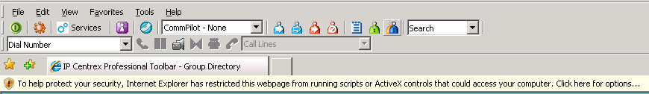

This warning is triggered by the JavaScript used by Professional Toolbar to sort directory listings.

The following instructions safely override the warning and open the directory:

1. Click the message. The notification will display a pop-up menu.
2. Select Allow Blocked Content from the pop-up menu.

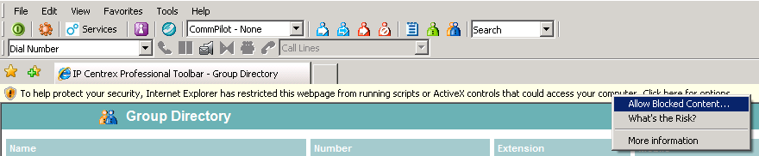

|  |  |
| --- | --- |
| 1. Another security warning then appears. 2. Click Yes. | SC40-3 |

Professional Toolbar Not Visible in Either Microsoft Internet Explorer or Microsoft Outlook

If Professional Toolbar is not visible in Microsoft Outlook, you should follow the steps below. If the problem is still not solved, you should contact your usual Spark Digital Helpdesk number.

To confirm that Professional Toolbar is installed:

1. Open Internet Explorer.
2. Click the Options icon (or the Tools icon in IE7) in the toolbar space.
3. Click General in the tree view on the left of the Options dialog window. (In IE7 click on Programs tab, and then on Manage Add-ons)
4. Verify that the “version” area of the page lists Telephony Toolbar Call Control and Telephony Toolbar Services. If it doesn’t then you should contact your usual Spark Digital Helpdesk number. If it does list these then you should proceed to the next step.

Make Professional Toolbar visible:

1. Right-click an empty area of the toolbar region in Outlook. A menu appears listing all the toolbars currently registered.
2. Make sure that the Professional Toolbar entries (Telephony Toolbar Call Control and Telephony Toolbar Services) are checked, as shown below.

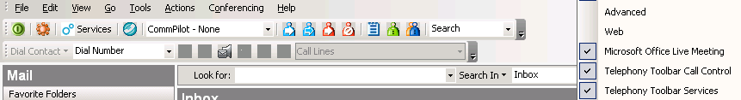

1. If the Professional Toolbar entries are not listed, you should continue to the next step:

Register Professional Toolbar within Outlook:

|  |  |
| --- | --- |
| 1. Click on Help then About Microsoft Office Outlook. 2. In the dialog box select Disabled Items. If the Telephony Toolbar related items are visible on the list, click on Enable and restart Outlook. |  |

Error Message – “You have not been licensed to Use IP Centrex Professional Toolbar. Please contact your service provider”

This error indicates that you are trying to use the toolbar with an IP Centrex Basic phone and you don’t have a Client License to use the toolbar.

In this case you should contact Spark Digital to activate a different service pack for your IP Centrex phone that will allow you access to the Professional Toolbar.

Professional Toolbar is Not Visible in Internet Explorer

If Professional Toolbar is not visible in Microsoft Internet Explorer, follow these steps:

1. Right-click an empty area of the toolbar region in Internet Explorer. A menu appears listing all the toolbars currently registered.
2. Make sure that the Professional Toolbar entries (Telephony Toolbar Call Control, Telephony Toolbar Services ) are checked as shown below
3. If the problem remains you should contact your usual Spark Digital Helpdesk number.

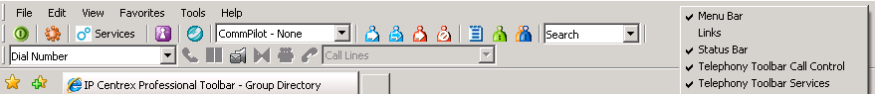

End of Document